I Did It My Way vs. Trusting God's Way
February 18, 2017

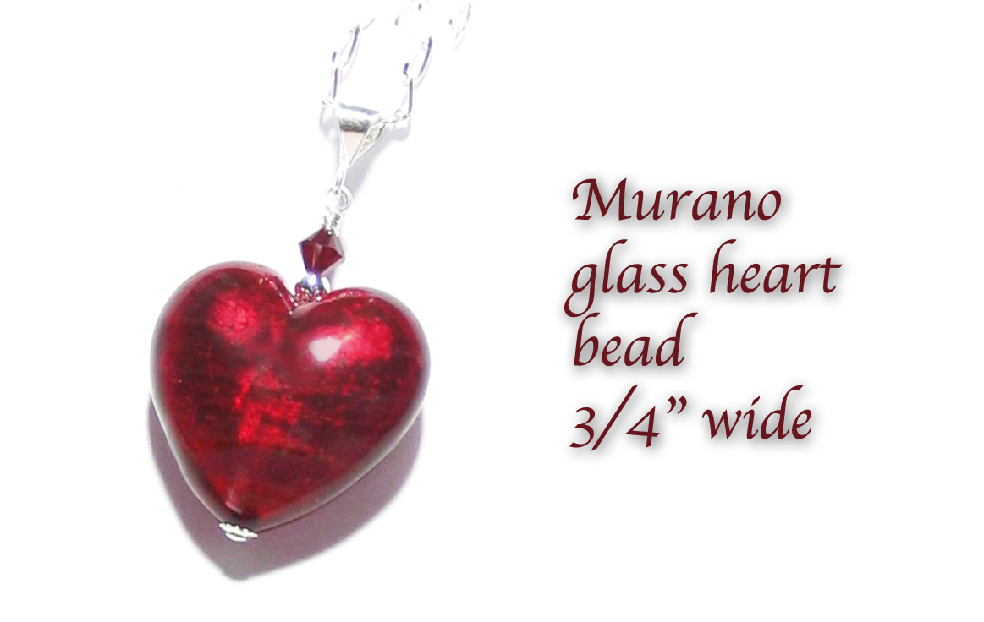
Well, I hope this incident spares you, precious friends…the pain I’ve gone through today. It really seems like a petty thing. I'll try to explain it. But it's been SO very hard. A lot of tears. And over such a little thing.

Here’s the story.

In prayer several days ago, the Lord gave me a beautiful red heart necklace, the heart being about 2” or 3” wide. He placed it around my neck. And I got the impression He wanted me to have one similar to that, that would remind me of something He was doing in my spirit. Something new and full of hope and faith.

Well, I suppose women are more subject to this tendency than men - wedding rings and anniversary presents and what have you. But I always love to have a sign from Him, something to wear, to remind me of His promises. Or of something - even a rock with an image on it. The rocks do cry out, you know!

Not anything expensive…not fine jewels - although the faceted, gem-quality aquamarine my father bought for me before he left us was surely expensive. But just something very small. I see my wrists all the time when I'm playing music and for Valentine’s Day He let me get a very small silver bracelet with tiny garnet hearts from India. I haven’t received it yet. But when I do, I will put a $2.00 medal of the shroud of Turin on it to remind me of what He suffered for us.

So, I went window shopping on Amazon and found a beautiful, red, Venetian Murano glass heart that was absolutely perfect. What I didn’t understand was the size…it said 20mm and I thought that was large. Whoops…that’s only 3/4 of an inch. I didn’t find out until it arrived here how tiny it was and I was crestfallen. I was going to return it, but then I thought of someone that I loved that I wanted to give it to. So, I saved it.

And I found a lady on Unicef who makes larger hearts out of epoxy resin, and her work is beautiful. She had a much larger heart, closer to the size I wanted - but not the right color. So, I wrote to her and she was very receptive, willing to make one for me. By the way, we’re talking about $20 here. So, it was within my budget.

Well, I started to feel funny…like something wasn't right between Jesus and I. And I started getting Repentance from the Bible Promises. Not once but two and three times. A couple days in a row, actually.

Now, I was also helping people with their electric bills, food and rent. So, I was not ignoring the needs of others. But Jesus made it clear to me through my husband that I could not have her make one for me.

I was really upset, crestfallen and didn’t understand. I had looked so hard and finally found someone and He was saying, “No.” I felt baited, teased, and unworthy. Like, "Your heart is tiny, you should stick with tiny." No doubt that was the enemy, but when I looked at the heart I said, “Lord, is my heart that tiny? But you gave me a bigger heart…"

Well, after several hours of struggling with His decision, and a lot of tears - I finally came to Him in prayer: I don’t know what to say to you, Jesus, except that I am sorry for my sinful ways. And it is true, I do hurt, because I thought this was the right thing. You know my first response was to say “NO! This is too much. I don’t want anything but You, Lord.”

Then You seemed to be saying, “Yes, I want you to have this token of Love.” Then I found the heart but it was SO tiny. What I saw was much bigger. So, I continued looking…you know all of this. I found that lady who could do it for next to nothing and you still said, "NO." By then I was “hooked” and really excited. So, it hurt. I don’t understand. I really don't understand. Please help me. I'm so disappointed.

Jesus began, "My Love and Lovely one, would I deny you something that would be good for you?"

He was holding my hands as we sat in the garden. I answered Him, “No.”

He replied, "Do you trust Me?"

Yes.

"Then let it go. Let it go, Clare." (lots of sniffles and tears)

O.K. (More tears, gushers.) Lord, I don’t understand, it feels like You were teasing me.

He answered, "This is more about self-will and abandoning yourself to My providence."

O.K. I can understand that.

"Letting it go, letting it go, letting it go. (as Julie True sings) And as you let go, you give Me the freedom to work in your soul as I would like to. And very much of this is about trust and doing it My way, or rather abandoning yourself and letting Me do it My way."

I wish I had understood this before I started looking.

"You are stubborn, Clare. It is hard for Me to turn your head once you get going."

That reminds me of when I was a young girl going horseback riding. Some of these horses in the stables were real nags, boy. You tried to turn them and they just keep going straight. That was the vision I got when He said that.

I replied, "Yes, I know this, Lord. It is a fault, that can easily lead to sin."

He replied, "That is why I have to push the brakes to the floor in your conscience or you don’t listen. If you would take a clue earlier on, it wouldn’t cost you so much. This cost you much today. And beloved, your very real enemy gets on your back and rides you like a race horse to his appointed finish line - not Mine."

How do I avoid this?

"Refuse to get in the race."

But I had permission, even from my covering. And Your permission.

"There was a point where I wanted you to stop and you kept going. You are aware of that aren’t you?"

I cannot make excuses before You, Lord. I was feeling like the panther got out of the cage, but I justified it that when I finally found the right one, it'll be over.

He answered, "I knew that what you had settled on would disappoint you because it was too small, even before you ordered it. You didn’t ask Me if that was the one, using the Bible Promises. And I let you move ahead anyway. When you got it, I didn’t want you going out to find another one. I wanted you to lay down with it, and accept it.

"But your perfectionistic streak was over-riding My still small voice in your heart. And now I am asking you to drop it, let it go. Will you do that, Clare? For Me? A little sacrifice. It doesn’t change the gift I gave you in the spirit, not one bit. But it does do violence to your self-will and stubborn, perfectionistic character fault. I really would like to see that thing dead before you leave Earth."

Lord, Your grace is sufficient for me. It hurts, but I will do as you ask anyway. (I glanced over at His portrait and He was smiling at me for the first time in days.) Your Grace is sufficient.

"What is hurting you more than anything is that you didn’t get your way. That’s the monster I want to kill. Your way. Do you know that I can provide you with a gift like that straight from Heaven…without any earthly intervention? But your willingness to let it go is SO very, very pleasing to Me and a great exercise in humility. Just like with the Collie. You looked for the right dog and couldn't find it. When finally you got it, you said, 'Lord, I'm going to wait on You.' And I provided it with no effort on your part. And then you knew that it was truly Me that was providing it. It takes all the traps of pride and self-serving, selfishness, right out of your hands and character.

"AND THAT is pleasing to Me.

"So, allow Me, Clare. Lay it to rest and allow Me to do it My way. By the way, you are no different than a great sector of Earth’s population. Frank Sinatra said it for them all, 'I did it my way.'

"Come now, My Darling Bride, let us leave this sadness behind and be refreshed in My grace that nothing is impossible to those who believe. And it is always better to do it My way.”

